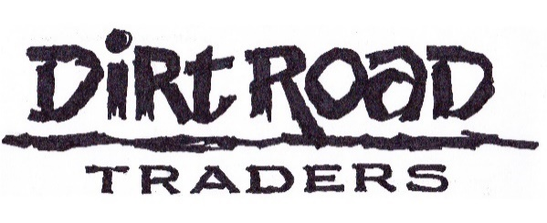
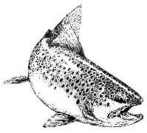
Dirt Road Wild Trout Festival 17th to the 21st March 2027

Participation application form

Please complete legibly and return to: dave@wildtrout.co.za

Name: Age

E-mail address: Cell no:

Name of non-fishing partner, if applicable

Have you fished in the area before? Yes/no Do you require a sheppard?* Yes/no

Other requirements? (Vegetarian meals/allergies?)

Beat preferences, if any?

Package details:
- The Full Monty; 5 evening meals, 4 days of fishing, 4 lunch-packs, plus participation in the event auction as well as bar banter at no charge
- Partner package as described below
The assistance of a sheppard must be arranged each evening during the event. Ensure that you make contact with the beat organisers, Heather & Rudi to make the appropriate arrangements on a daily basis.
RATES, 2027
Dinners, Fishing, Lunch-packs and Shepparding - by arrangement | R8500
Non-fishing partner; i.e. including dinners but excluding fishing & lunch-packs | R2950
T’s & C’s
- All applications will be dealt with on a first come, first served basis.
- Kindly complete and submit your application form as soon as possible.
- There will be no preferential treatment for applicants who have attended previous events.
- Applicants will be advised regarding acceptance or not by 30th June 2026
- Payment of a 50% confirmation deposit is required by the 31st July 2026
- The balance due must be paid by 31st October 2026.
- Participation is at own risk and the sheppards are in no way responsible for participants’ health & safety on the water or elsewhere, for that matter.
- CANCELLATIONS; In the event that a cancellee may know of a replacement, please advise accordingly i.e. Name, e-mail address and cell number.
- Refunds will be subject to an administrative fee of 30%.

- Banking details
- Wild Trout Association, FNB, Barkly East, 210220. Acc. no: 51610009669, Current acc.
- Use “Fest 2027” & your SURNAME as a reference
- Please e-mail the EFT PoP to dave@wildtrout.co.za and CC rudi@rhodesinfo.co.za for good measure

Accommodation & Breakfasts
- Catered/B&B or self-catering accommodation should be arranged with Xolelwa Yaleko at the Rhodes Tourist & Information Centre: Tel. 045 971 9003 or e-mail: info@rhodesinfo.co.za
- Although the festival includes 4 days of fishing, participants are welcome to arrive earlier to fish in the Eastern Cape Highlands - after all, a bad week’s fishing beats a good week in the office any time!
- Breakfast @ Walkerbouts; Bookings can be made by sending an e-mail to bookings@walkerbouts.co.za by 28/2/2027

